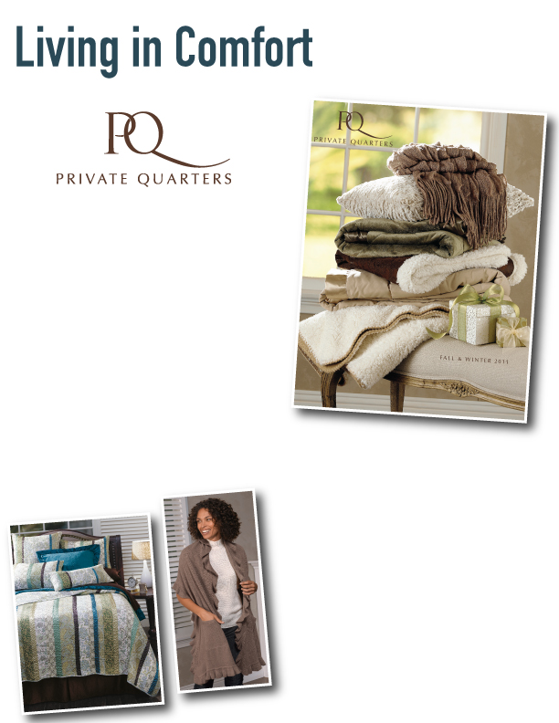
Come join us!
Give your home a fresh new look this season with something new from Private Quarters! From sumptuous sheets to a bevy of cushy cotton towels and linens, our PQ Comfort Consultant will show you how to affordably slip into the season in style. You’ll be among friends as you sip, snack and shop your way through our exciting selection of fall products—including the latest comfortwear and accessories. Whether it’s your gift list, or a room in your home that could use a little makeover, this is your chance to spring into action! Join us, won’t you? And, make sure you bring a friend! You won’t want to miss the fun!

Date: November 30th

Time: 6:30 p.m.

Host: Brian Cullinan
Address: 9259 E. Raintree Dr., Unit 2164

RSVP: 614-425-6054

Consultant: Linda E. McVey, lemcvey@cox.net, www.privatequarters.net/linda

Click here to shop, but you won’t want to miss seeing the products and having some fun!

